CSEN 60 Lab 2 Instructions

This lab will test your ability to style an html page to match a given mockup,

Before getting started

* Download the [lab2-starter linked here](https://drive.google.com/drive/folders/1Fe1UW0hBEdywz18NZoZRNQeMiHbdVRse?usp=drive_link).
* Rename it to lab2 and add it to your git repository under labs.

Instructions

Your goal is to style the html page to look like the following mockup ([here is a link to a better quality image)](https://drive.google.com/file/d/1sOd642_Mk0sogkGTp0wH2C8zsGq1fcAc/view?usp=drive_link):

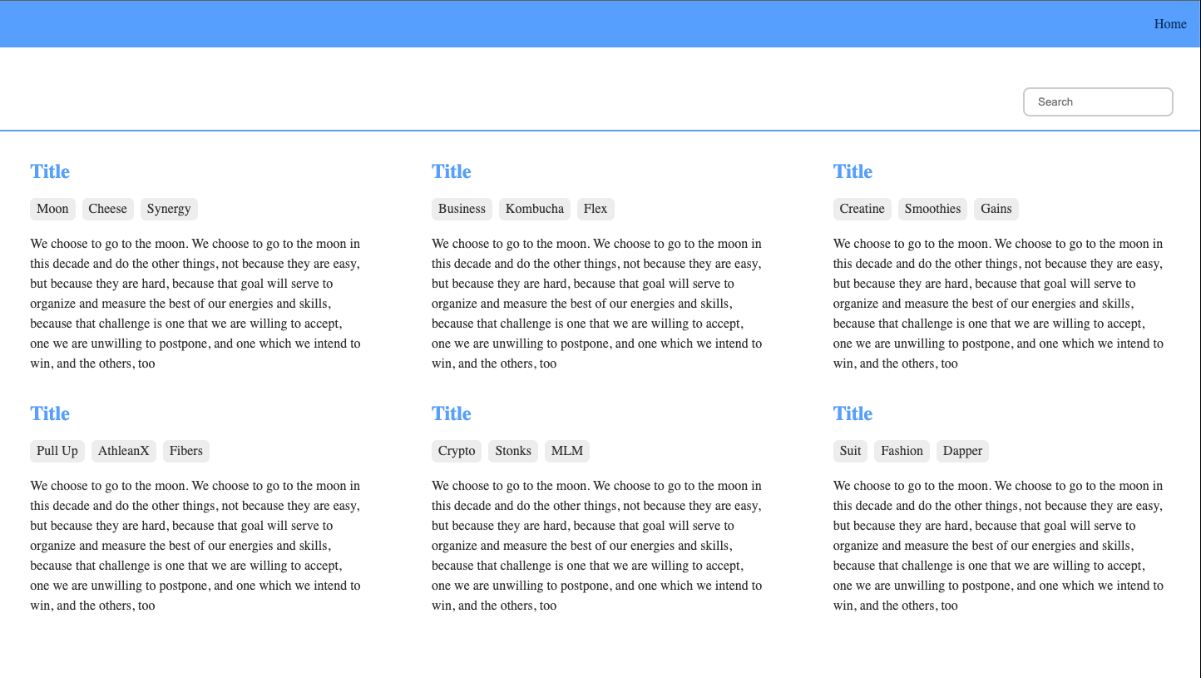

Here is the mockup on a smaller screen size:

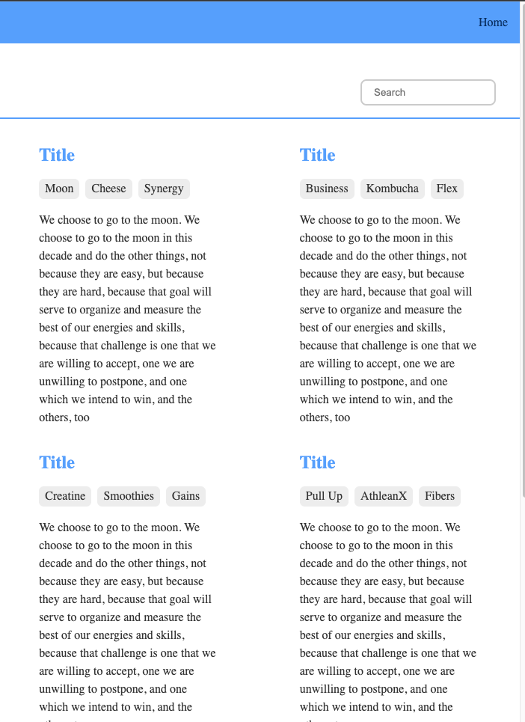

You are given a complete html file and two incomplete CSS files – base.css and all-articles.css – which are located in the styles folder. Some of the rules have the suggested properties and all you need to do is find the correct values for them. Others are empty and let you decide how to achieve a given style.

What’s provided is a starter guide. If you’d like to achieve the same styling using different rules and properties, you are free to do so. I’m even fine with you using a styling framework like TailwindCSS if you are familiar with it. The ultimate goal is to style the html page to look like the mockup.

Tips:

* Link your CSS files in the html. Base.css should be first.
* Use flexbox for content layout.

Demo and Submission

* Show the TA your website to receive demo credit.
* Commit all the changes you made to your git repository and push those changes to github
* Submit the Github link to the lab2 assignment.

# Grading Criteria

| **Criteria** | **Points** |
| --- | --- |
| Correct visual styling of web page | 80 |
| Correct visual styling at a smaller screen size | 10 |
| Demo | 10 |